**CHAPTER 2 GETTING INFORMATION FROM A TABLE**

**2-2 Overview of the select statement**

The select statement is used to get some of the data from a table. It has six clauses(从句):

select Which columns of data to get

from Which table has the data

where Which rows of data to get

group by (Described in chapter 12)

having (Described in chapter 12)

order by Which columns are used to sort the result

A select statement is often called a ***query***.

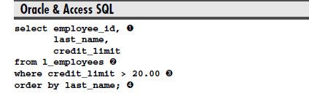

**2-3 Overview of the select clause**

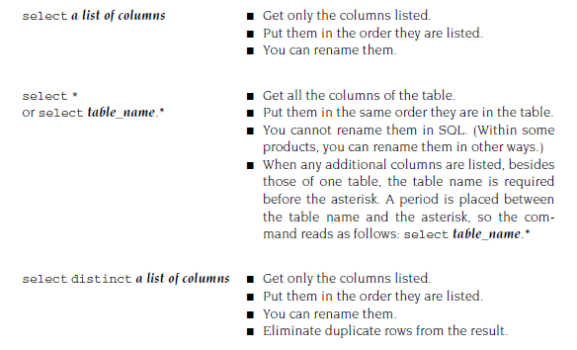Distinct eliminates all the duplicate rows from the result table.

**2-4 Use a select clause to get a list of some of the columns**

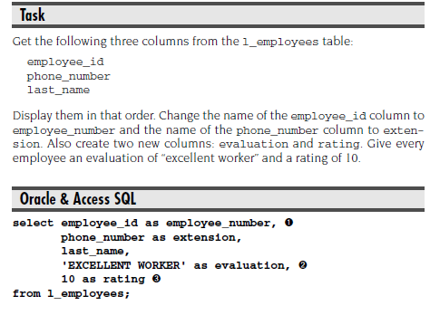

➊ The employee_id column is being renamed employee_number.

➋ The text 'EXCELLENT WORKER' is added to every row of the result table in a column called evaluation. This is an example of placing a literal value in a select statement.

➌ Here the literal value is a number, so it is not enclosed in quotes.

**2-5 Use a select clause to get a list of all of the columns**

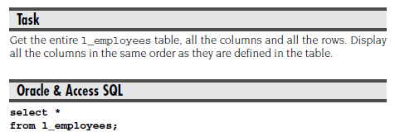

**Oracle & Access SQL: Variation 1 — Adding a where clause：**

**select \***

**from l_employees**

**where manager_id is null;**

**Oracle & Access SQL: Variation 2 — Adding an order by clause：**

**select \***

**from l_employees**

**order by last_name;**

**2-6 Use a select clause to get the distinct values in one column**

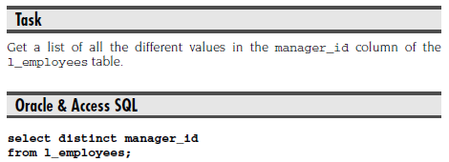

**Oracle & Access SQL: Variation 1 — Adding a where clause to select distinct：**

**select distinct manager_id**

**from l_employees**

**where employee_id in (201, 208, 210);**

Select distinct may be used with a where clause to limit the number of rows in the result table. The where clause is processed first, which removes some rows from the beginning table. Then the select distinct clause is processed.

**Oracle & Access SQL: Variation 2 — Adding an order by clause to select distinct：**

**select distinct manager_id**

**from l_employees**

**order by manager_id desc;**

**2-7 Use a select clause to get the distinct values in two columns**

**Task：**

Get a list of all the different values in the manager_id and credit_limit columns of the l_employees table.

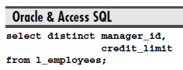

**2-8 Overview of the where clause**

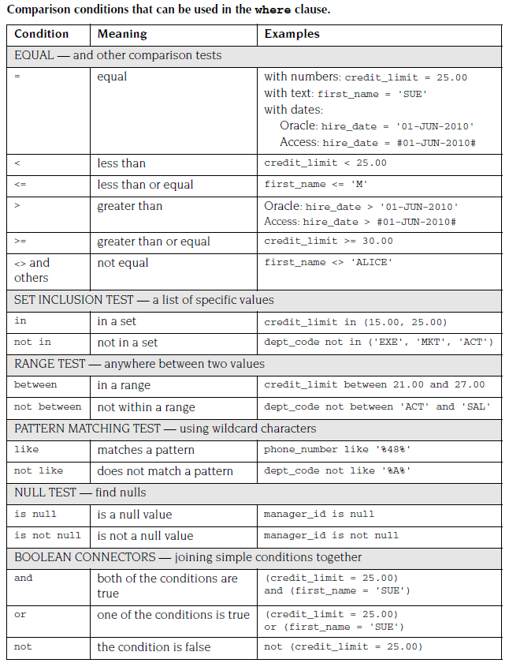

**2-9 Using an Equal condition in the where clause**

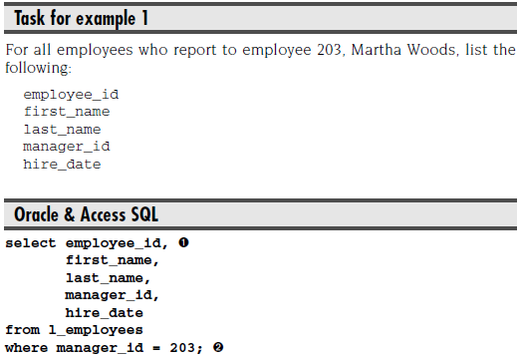

**Task for example 2：**

For all the employees whose first name is Henry, list the same columns as before.

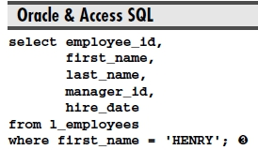

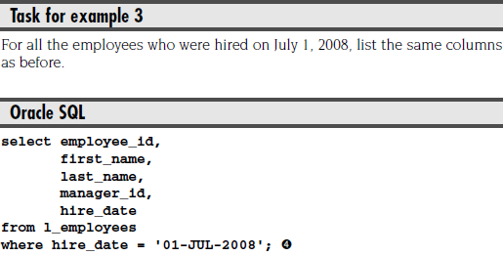

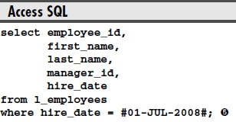

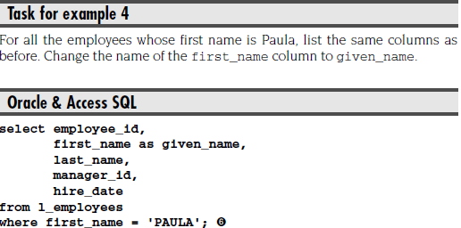

**2-10 Using a Less Than condition in the where clause**

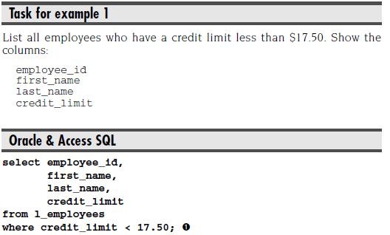

**Task for example 2：**

Show another way to write this query, using the greater than or equal to (>=) sign and negating the condition with a Boolean not.

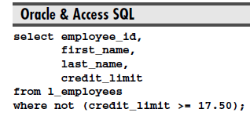

**2-11 Using a Not Equal condition in the where clause**

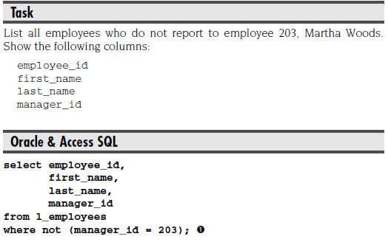

Variations

Some other ways to write the Not Equal condition are as follows:

**where manager_id <> 203**

**where not manager_id = 203**

**where manager_id != 203**

**where manager_id ^= 203**

**2-12 Using the in condition in the where clause**

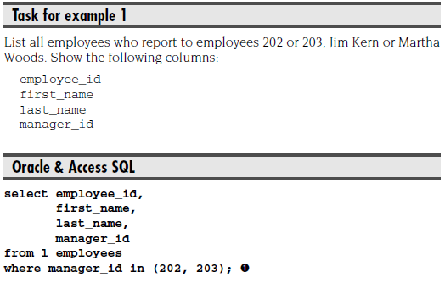

➊ This condition means that the manager_id column is equal to either 202 or 203.

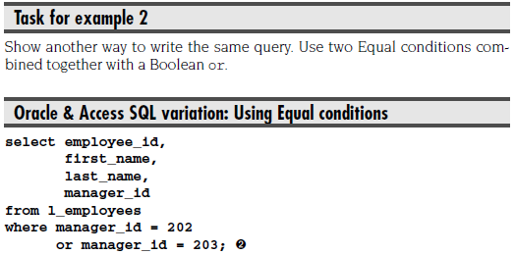

➋ You must repeat the column name, manager_id, within each Equal condition.

**2-13 Using the between condition in the where clause**

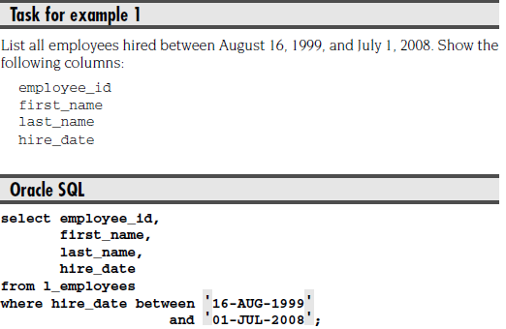

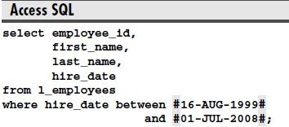

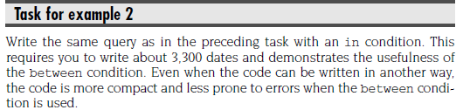

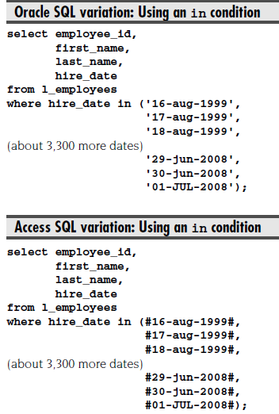

**2-14 Using the like condition in the where clause**

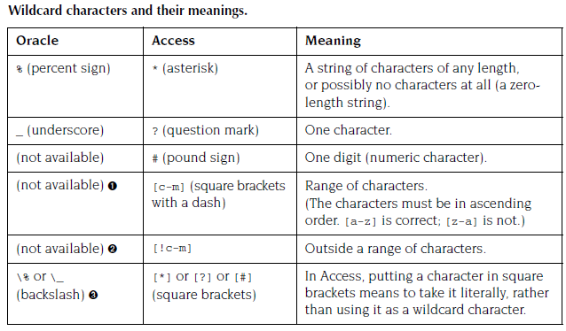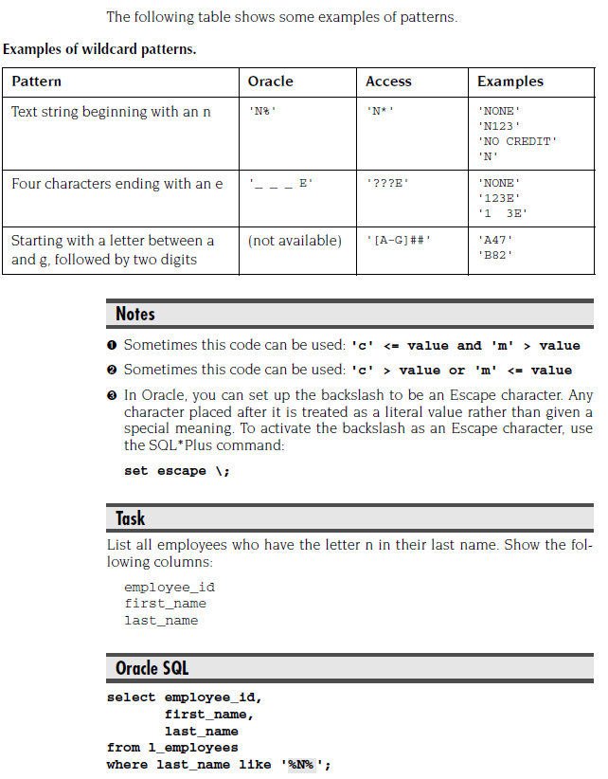

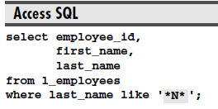

**2-15 Using the is null condition in the where clause**

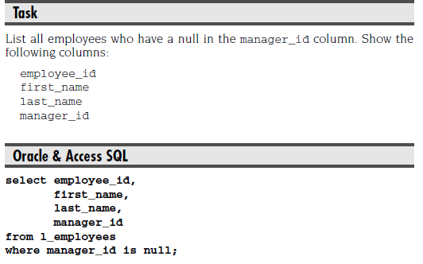

**2-16 Overview of the order by clause**

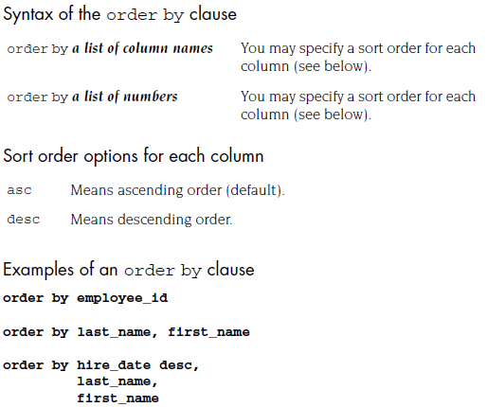

**2-17 Sorting the rows by one column in ascending order**

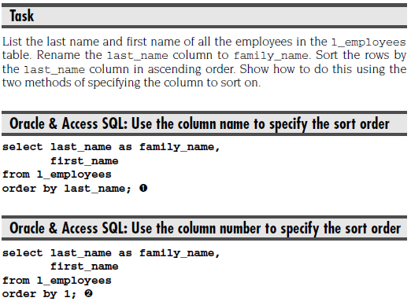

**2-18 Sorting the rows by several columns in ascending order**

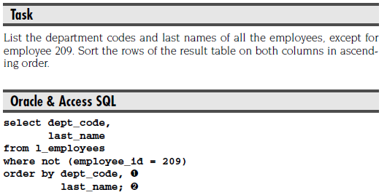

➊ The rows of the result table are sorted first and primarily on the dept_code column.

➋ The rows with identical values in the dept_code column are then sorted on the last_name column.

**2-19 Sorting the rows by several columns in various orders**

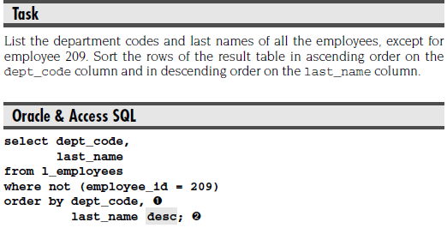

➊ The rows of the result table are sorted first and primarily on the dept_code column.

➋ All the rows with the same value in the dept_code column are sorted on the last_name column in descending order. This is applied twice, once with the SAL department codes and again with the SHP ones.

**2-20 The whole process so far**

